Congregational representatives speak out at Public Hearing of Joint Committee of the Australian Parliament.
Following the lodging of submission to the Foreign Affairs and Aid Sub-Committee Inquiry into the Strategic Effectiveness and Outcomes of Australia’s Aid Program in June, the Inter-Congregational Voice on Climate Change in the Pacific was invited to attend a public hearing in order to address the Committee and answer questions.
The Inter-Congregational Voice on Climate Change and the Pacific Islands is a group of Catholic Religious Congregations with historical and ongoing involvement among peoples in Pacific Island nations in the areas of education, health, community development and climate justice. These Congregations work with members on the ground in many Pacific Island nations and live and work among the people.
Consequently they bring a wealth of experience and personal connection to Australia’s Pacific Island neighbours and this has motivated them to join together in order to amplify the voices of communities they have worked with.
On July 2, 2018 Inter-Congregational Voice members Janice Ruff smsm, Lynne Crilley pvbm and Maria Tiimon Chi-Fang from the Marist Laity formed a delegation to attend the Masonic Conference Centre in Sydney.
In her opening address, Lynne Crilley explained that ‘Many of our members have witnessed and felt the pain of the impacts of climate change on the people’s everyday lives, their health, threats to their traditional life styles and fears for their future.’ ‘For many years Pacific Island nations have been asking industrialised nations to mitigate climate change and recognise their vulnerability.’
Speaking about the lack of attention to maintenance in the funding of aid projects Maria Tiimon Chi-Fang said, ‘We appreciate aid from the Australian government but I see water tanks in Kiribati and they have not been done properly,’ She added, ‘ Maybe Australia can say ‘that is your problem Kiribati’ but Kiribati is a poor country.’ She pointed out that people who come to Kiribati need to be well trained so that when they come they train the local community so that they can do things themselves.
The submission had asked the committee to recommend that aid projects be developed in consultation with local communities pointing out that this is important for the ongoing maintenance of projects and the skills acquired when people are part of the decision making for their own communities. Thus when Chris Crewther MP asked what new measures and targets for Australia should be Lynne Crilley said that aid projects should target local communities, talk to elders and leaders in communities and find out what is important to them. ‘Go and listen to the people to find out what they need and want. That would help to improve maintenance – if the locals are on board then maintenance problems don’t happen.
Janis Ruff reminded the committee that it takes a lot of effort to understand what people really want. She said ‘I’ve worked in Kiribati and Bougainville and even though I worked there a long time I still don’t have the mind-set of the locals.
Janice told stories to explain the attachment of the people of the Carterets to their own islands and the difficulties that come when people are moved. Maria Tiimon Chi-Fang who comes from Kiribati explained that people where she comes from ‘don’t want to move.’
Senator Moore assured the delegation that the committee would get an answer on maintenance and that they will make sure that there is more consultation with local people about projects.
When Sharon Claydon asked Maria how she thought Australia should best direct our aid to Kiribati Maria replied with two main points; first she spoke of ‘education for young people so young people can get jobs’ and then she pointed out that ‘we need the rich countries to cut back their greenhouse gas emissions so the poor people o fmy country can stay in the country they love.’
The submission had expressed concern that Australia seems reluctant to be involved in meaningful Loss and Damage finance as vulnerable countries deal with the adverse effects of extreme weather and slow-onset events such as sea-level rise. Maria Tiimon Chi-Fang spoke with great passion about the need Pacific Island nations have for Australia to take Loss and damage finance more seriously. She pointed out that ‘Australia is a rich country and just next door to Pacific Islands and needs to show solidarity.’ She said that from what she understood Germany is doing more than Australia. She also explained that Loss and Damage that is arising because of climate change is not just about land and homes but also about human beings and culture.
When Crowther M.P. asked should there be research on volcanoes in Antarctica and their effect on climate change there was a stunned silence from the delegation followed by vague answers. Eventually, Janice Ruff said, ‘We keep side-stepping the elephant in the room: coal –fired power plants’. Later on, Janice asked the committee to consider the irony pointed out in the submission of ‘the huge subsidies that Australia gives to the fossil fuel industry (conservatively estimated to be approximately $5 billion per year) compared with the $300 million over four years (from 2016-2020) for climate change and resilience in the Pacific region.’
Claire Moore agreed ‘We need to do research but there is the reality of what is happening now.’
The delegation asked the committee to ensure that the causes and effects of climate change be key to the design of Australia’s Foreign Aid program while at the same time ensuring that money for climate mitigation and adaptation be over and above normal overseas development assistance . They expressed sadness that the amount of overseas aid has gone down so much and asked that it be increased to ).7% of Gross National Income.

July 2, 2018 Inter-Congregational Voice on Climate Change for the Pacific at Public Hearing: Foreign Affairs and Aid Sib-Committee Inquiry into Strategic Effectiveness and Outcomes of Australia’s Aid Program, at Masonic Conference and Function Centre.
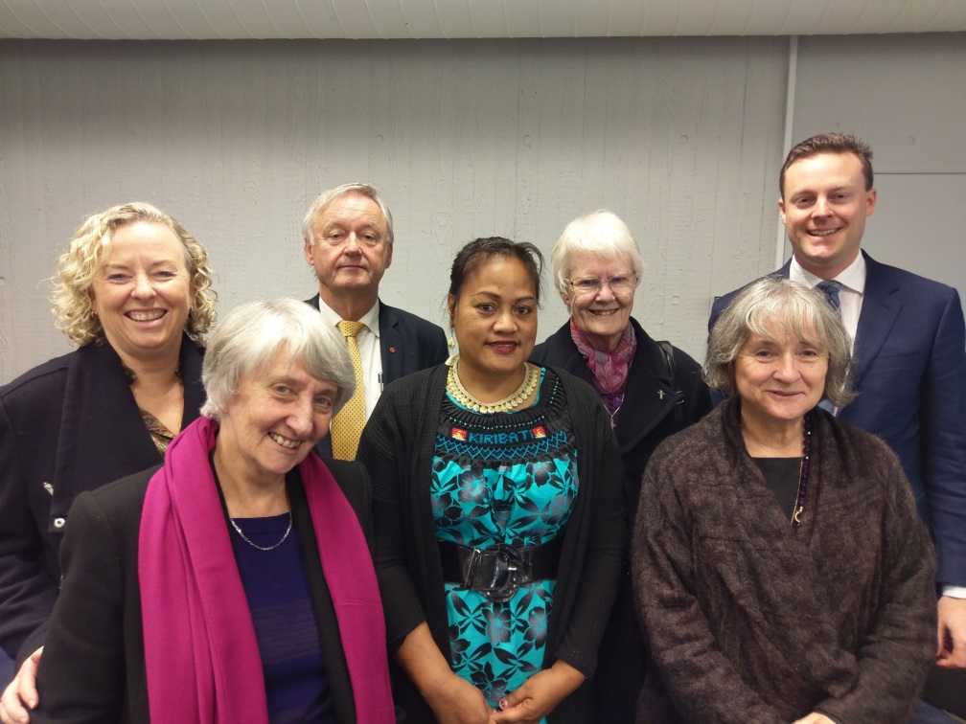
Ms Sharon Claydon MP Sr Lynne Crilley pbvm Senator Alex Gallachor (Deputy Chair), Maria Tiimon-Chifang, Sr Janice Ruff smsm, Senator Claire Moore, Mr Chris Crewther MP (Chair),

The most significant response that came from the committee members was a strong recognition of the unique experiences, relationships and understandings that members of members of the Inter-Congregational Voice. The committee members acknowledged that congregations have come into personal contact the impacts of climate change on everyday lives and with development assistance projects that are effective.
They committee members assured the delegation that the voices of people of faith are significant and that so too are the voices of people who have lived and worked in Pacific Islands. Besides telling the delegation that they did not need to be nervous, they pointed out that because of their experiences they are able to make a significant and unique contribution to understanding of these issues in the parliament.
Following on a sincere commendation of the delegation they issued a challenge to make the Inter-Congregational voice even louder. ‘With your credibility and networks you can do a lot to influence members of parliament’. They then made the following suggestions
- ‘You would have a big impact if you were to organise for congregational members to visit the National parliament in Canberra for a few days each year to meet with MPs and senators to share your stories, experiences and concerns. (you could get contacts and planning strategies from ACRATH and MICAH)’
- Get a local member to help organise the meetings
- Organise a meeting with DFAT (a DFAT representative who was present gave them his contact details and offered to help to put the Inter—Congregational Voice in touch with the right people in DFAT.)
After taking a photo and enjoying a general conversation with the committee members the delegation prepared to leave. As they left they were assured: ‘This issue is with us. There is the reality of what is happening now and Congregational members are witnesses to that.’
The Chair, Chris Crowther MP said in closing, ‘Thank you for your passion and your time to advocate on these issues.’

Reflection over coffee after the experience
Some snippets
Janice: ‘as I sat there in front of the committee I kept seeing in my mind’s eye some of our neighbours in water - like the neighbour who used to do the fishing for us – and his wife’s face the day a big storm broke - they had never seen anything like it before.
‘I wanted to say to the committee ‘we can mitigate greenhouse gas emissions but we can’t control climate change.’
‘In all my reading the bottom line in Australian aid seemed to come up as money!’
Maria: ‘I have mixed feelings. My first time with you two. We were so nervous before going in. We should be so proud as we did well.
Lynne: I felt that they understood our values and where we were coming from and also I felt that our credibility with them is genuine. They were never patronising. They understood the faith-based approach and our strong connections with the Pacific`
The group talked in practical terms about the possibility of organising visits to Canberra and decided to meet further in order to formulate items for discussion at the next meeting of the Inter-Congregational Voice on Climate Change and the Pacific Islands .

Fr Claude Mostowik who attended the inquiry as an observer said afterwards, ‘This was a very positive meeting with the politicians. They were very affirming of the participants and their credibility. They cited their past meetings with ACRATH in Canberra. The participants were praised by the Deputy Chair and encouraged by Senator Moore to not be bashful and lobby DFAT in similar ways that ACRATH has been doing.’

